# Assignment 2

Q1. Create an array A with elements (12, 13, 14, 15, 16) and display them

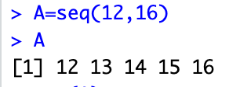

Q2. Find the sum of all the elements of A.



Q3. Find the product of all the element of A.



Q4. Find the maximum and minimum element of A.

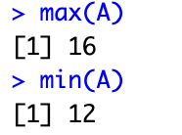

Q5. Find the range of array A

.

Q6. Find the mean, variance, standard deviation and median of value of A.

